1. **So Far**:
   1. Ant matcher is a method which helps us to exactly look for this end point   
      and tries to secure the URL based on the configurations that we have applied such as
      1. hasRole(), hasAnyRole(), hasAuthority(), hasAnyAuthority(), permitAll(), denyAll() etc.
2. Besides ant matcher, we have other matchers too in spring security.
3. Spring Security has 3 kinds of matchers.
   1. Ant Matcher.
   2. MVC Matcher.
   3. Regex Matcher.
4. A little difference b/w Ant Matcher and MVC Matcher.
5. MVC Matcher uses Spring MVC HandlerMappingIntrospector to match the paths and extract variables.
6. 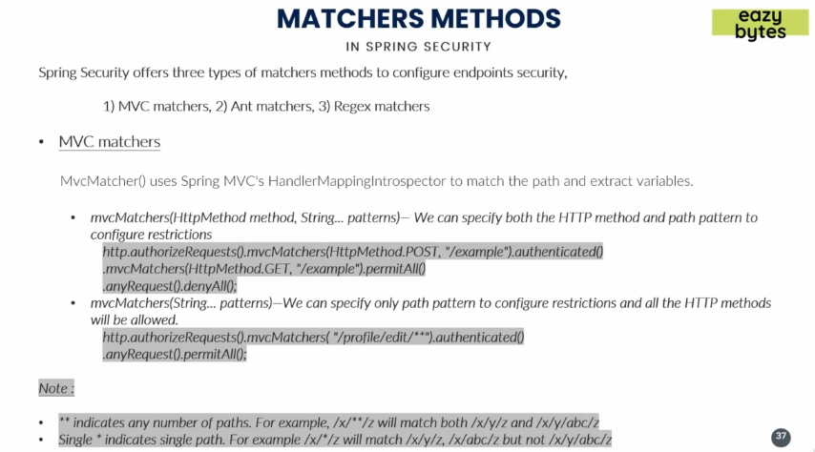
7. 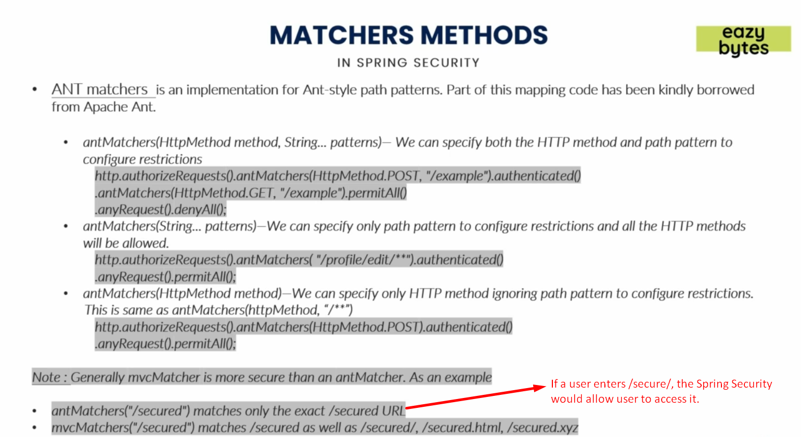
8. 